1. What is a Macro? How is it useful in excel or in your daily work?

ANS: A macro is a set of instructions used to execute repetitive tasks. You can record a set of commands and then play them back with one or two keystrokes. That means that you can save A LOT of time when doing routine and repetitive tasks. **Excel Macro** is a record and playback tool that simply records your Excel steps and the macro will play it back as many times as you want. VBA Macros save time as they automate repetitive tasks. It is a piece of programming code that runs in an Excel environment but you don’t need to be a coder to program macros. Though, you need basic knowledge of VBA to make advanced modifications in the macro.

* Importing the data
* Formatting it to meet your business reporting requirements.

1. What is VBA? Write its full form and briefly explain why VBA is used in excel?

ANS: Visual Basic for Applications (VBA) is part of Microsoft Corporation's [(NASDAQ: MSFT)](https://www.investopedia.com/markets/quote?tvwidgetsymbol=msft) legacy software Visual Basic. VBA is used to write programs for the Windows operating system and runs as an internal programming language in Microsoft Office (MS Office, Office) applications such as Access, [Excel](https://academy.investopedia.com/collections/excel-for-finance), PowerPoint, Publisher, Word, and Visio. VBA allows users to customize beyond what is normally available with MS Office host applications.

* Visual Basic for Applications is a computer programming language developed and owned by Microsoft.
* With VBA you can create macros to automate repetitive word- and data-processing functions, and generate custom forms, graphs, and reports.
* VBA functions within MS Office applications; it is not a stand-alone product.
* VBA is accessed in Excel by hitting Alt + F11 while having an Excel workbook present.
* VBA leverages objects, variables, properties, projects, logical operators, and modules to make statements recognizable by debugging processes.

3. How do you record a macro? Write detailed steps to create a macro to automatically make the following table in bold and to create borders for it in excel.

hi 78

hello 69

ineuron 45

Now that we have everything in place, let’s learn how to record a macro in Excel.

Let’s record a very [simple macro](https://trumpexcel.com/excel-macro-examples/) – one that selects a cell and enters the text ‘Excel’ in it. I am using the text ‘Excel’ while recording this macro, but feel free to enter your name or any other text that you like.

Here are the steps to record this macro:

1. Click the Developer tab.
2. In the Code group, click on the Macro button. This will open the ‘Record Macro’ dialog box.

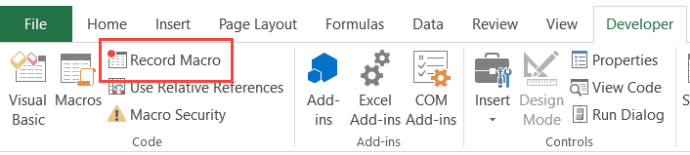

In the Record Macro dialog box, enter a name for your macro. I am using the name **EnterText**. There are some naming conditions that you need to follow when naming a macro. For example, you can not use spaces in between. I usually prefer to keep my macro names as a single word, with different parts with a capitalized first alphabet. You can also use underscore to separate two words – such as Enter_Text.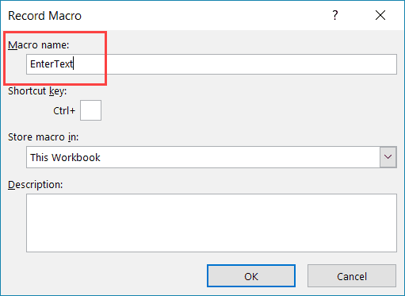

1. (Optional Step) You can assign a keyboard shortcut if you want. In this case, we will use the shortcut Control + Shift + N. Remember that the shortcut you assign here would override any existing shorcuts in your workbook. For example, if you assign the shortcut Control + S, you will not be able to use this for saving the workbook (instead, everytime you use it, it will execute the macro).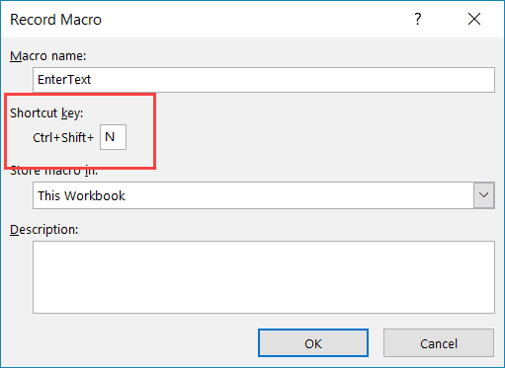
2. In the ‘Store macro in’ option, make sure ‘This Workbook’ is selected. This step ensures that the macro is a part of the workbook. It will be there when you save it and reopen again, or even if you share it with someone.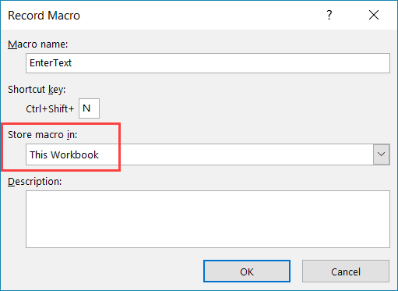
3. (Optional Step) Enter a description. I usually don’t do this, but if you’re extremely organized, you may want to add what the macro is about.
4. Click OK. As soon as you click OK, it starts to record your actions in Excel. You can see the ‘Stop recording’ button in the Developer tab, which indicates that the macro recording is in progress.
5. Select cell A2.
6. Enter the text Excel (or you can use your name).
7. Hit the Enter key. This will select cell A3.
8. Click on the Stop Recording button the Developer tab.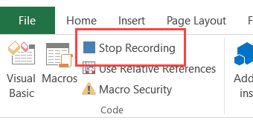

4 What do you mean when we say VBA Editor?

ANS: Visual Basic Editor is an application (a separate one) in which you can write and save all the VBA codes. In simple words, it’s a code editor for Excel in which you can write all the macros and store them. Even though it is a separate application (VB Editor) you can only use it with Excel.

5. Briefly describe the interface of a VBA editor? What is properties window? And what is watch window? How do you display these windows?

ANS:

A property refers to what an object has.

As an analogy, a car has a predefined set of properties such as color, size, type, engine, etc.

Likewise, an Excel object could have its own set of properties, such as color, font, and value.

Properties come after the object hierarchy.

This means that the object is specified first, followed by a period, then the property name, and the details or value assigned to it.

It also has to be specific in cases where there might be some ambiguity.

Taking a car and a shoe as examples:

Car.Color – might be too broad

Car.Interior.Color = Black – this makes sure that Excel knows which part of the car is being referred to.

Property Details

There are different property scenarios in Excel

1. Some properties don’t have details
   * Range(“A1”).Address
   * Range(“A1”).Value
2. Some properties return an object – this occurs when an object’s property is also an object with its own properties
   * Range(“A2”).Interior.Color – The Range A2 has Interior as its property, while Interior has Color as its property.
   * Range(“A2”).Font.Color

An interior property returns an interior object.

More details on this can be found through Microsoft Help.

Property Type

A property can be either read-only, write, or both.

Below are some use cases:

* Range(“A1”).Value = ActiveCell.Address
  + This reads the address of the active cell and puts it as the value of cell A1.
* Range(“A1”).Interior.Color = vbRed
  + This assigns the color red to cell A1’s interior.
* Range(“A1”).Font.Color = vbBlue
  + This changes the font color of cell A1 to blue.

6. What is an immediate Window and what is it used for?

ANS: Use the Immediate window to debug and evaluate expressions, execute statements, and print variable values. The Immediate window evaluates expressions by building and using the currently selected project.

To display the Immediate window, open a project for editing, and then choose Debug > Windows > Immediate or press Ctrl+Alt+I. You can also enter Debug.Immediate in the Command window.

The Immediate window supports IntelliSense.